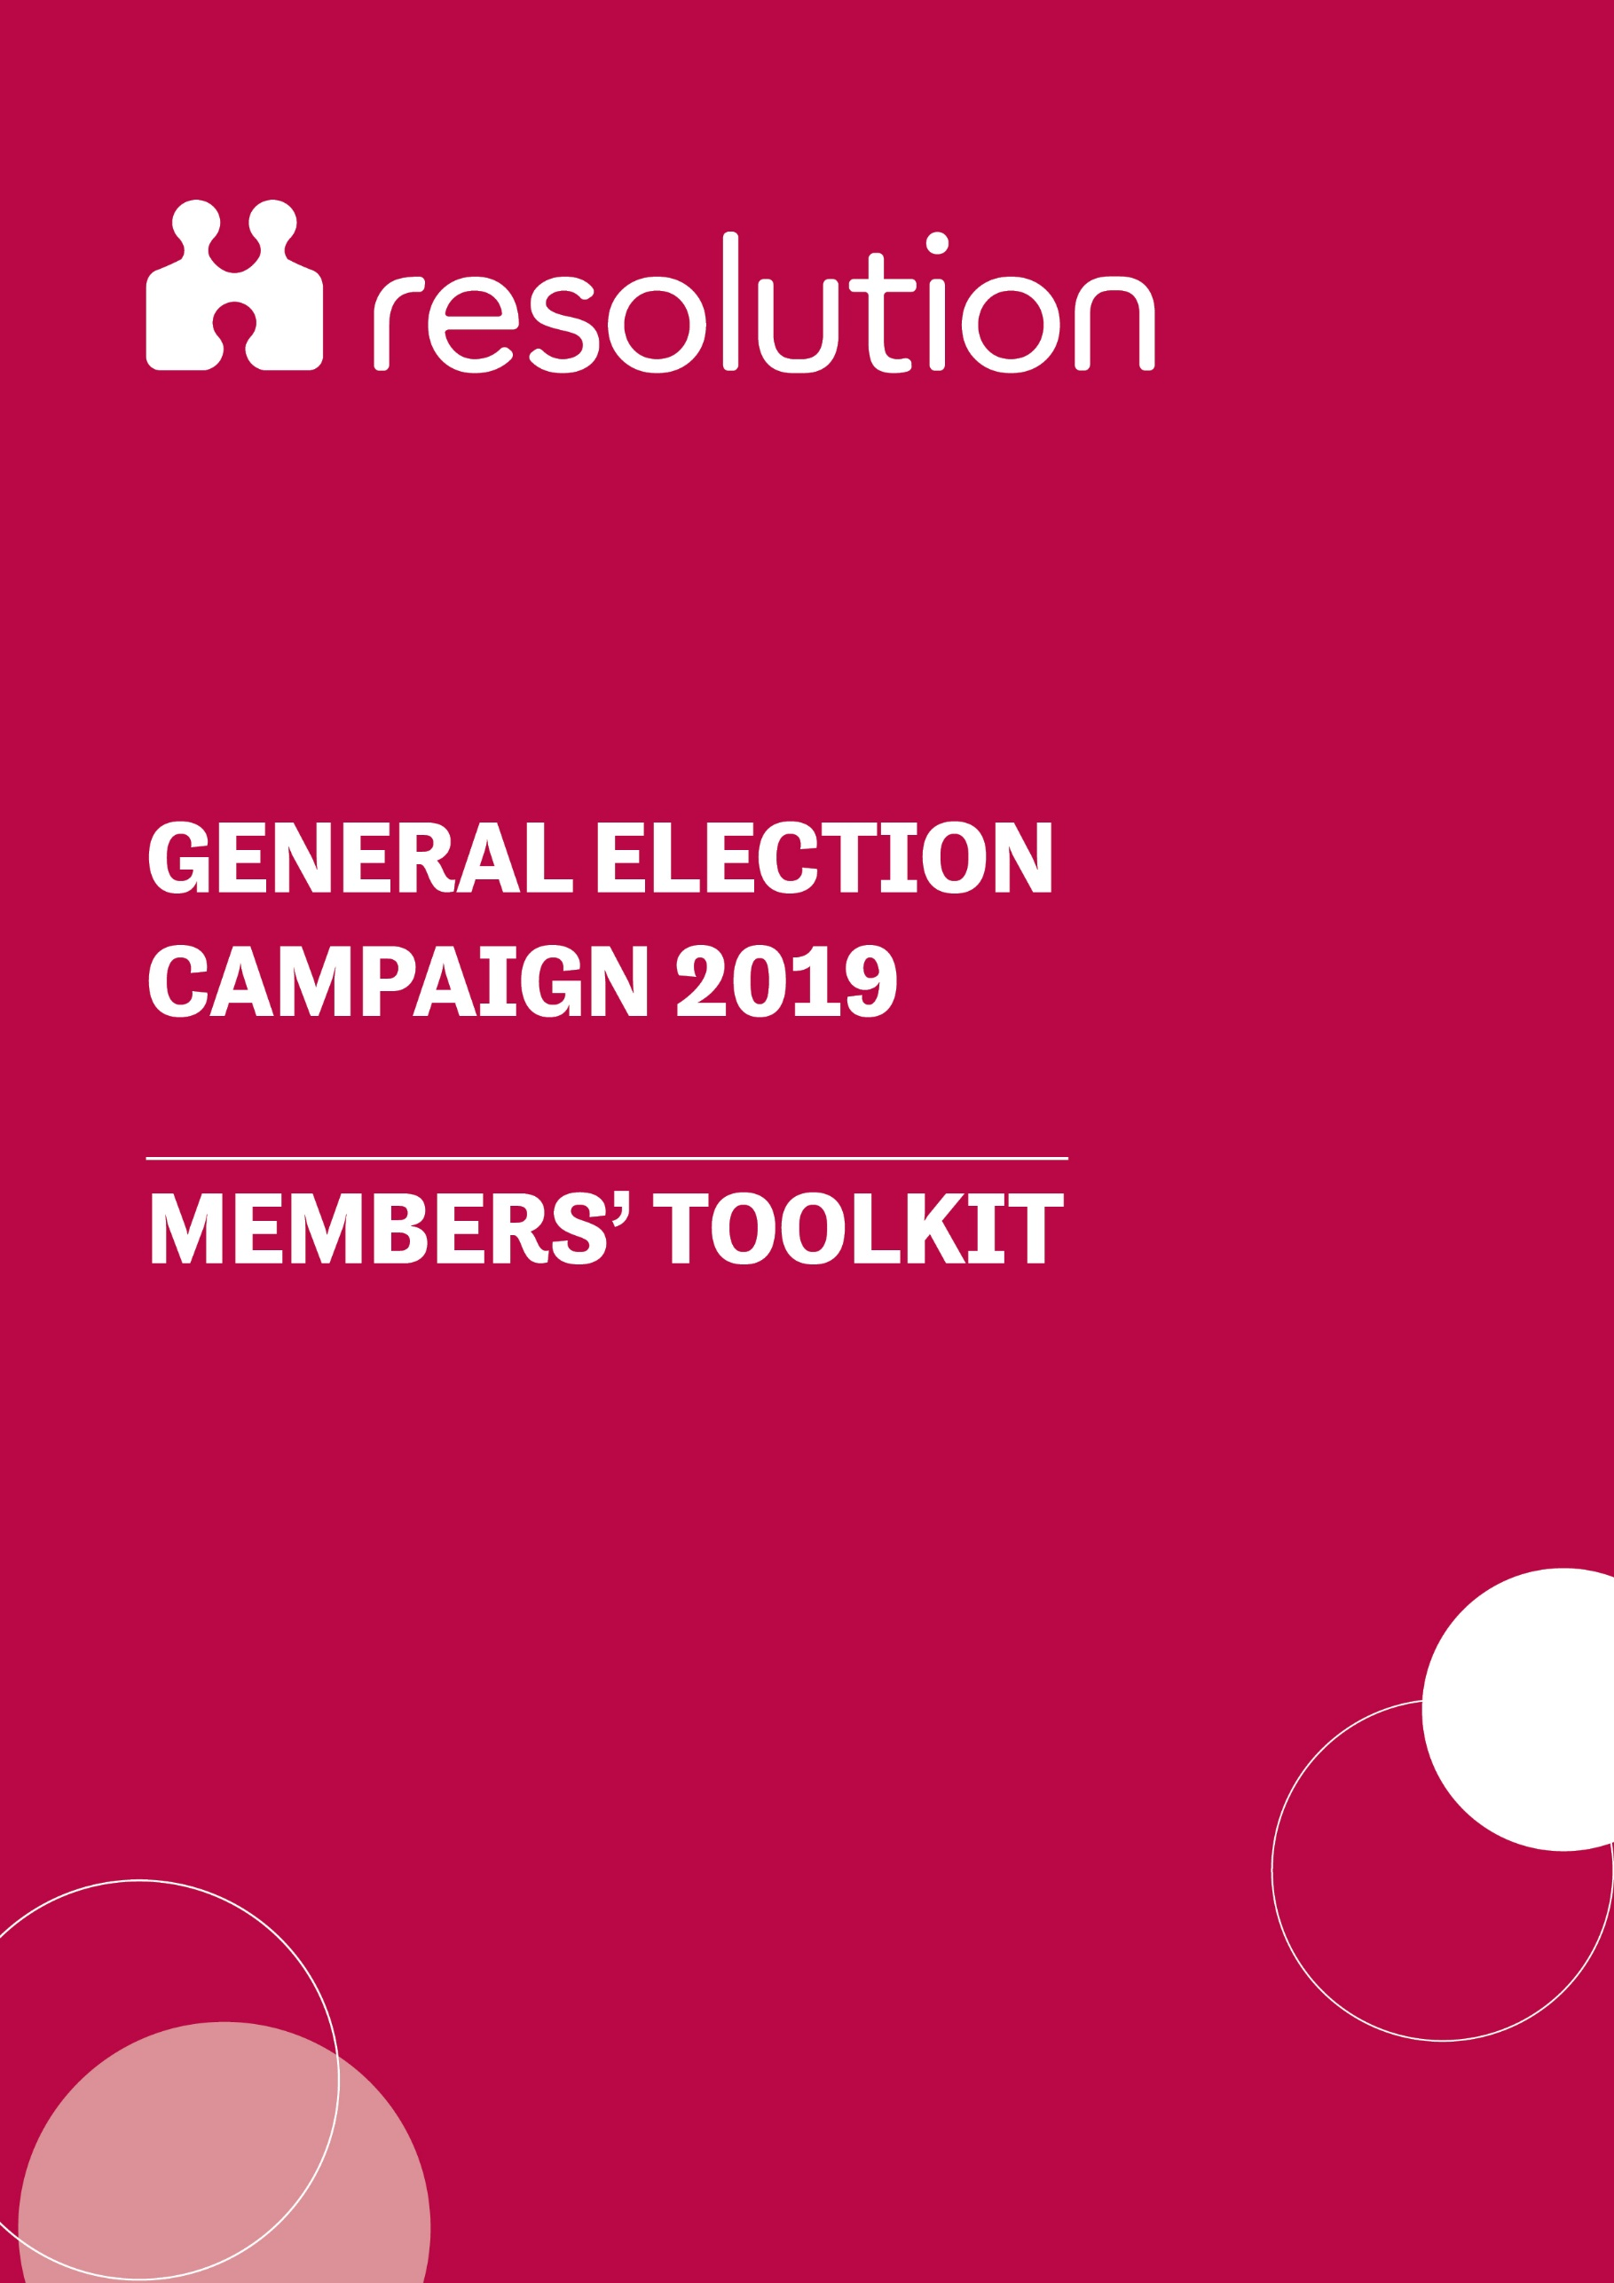
BACKGROUND

Over the past decade, Resolution’s campaigning and policy work has brought key issues to the attention of policy makers and led to real and tangible improvements for professionals and the families they help. Your support to help us bring no-fault divorce to the top of the policy agenda resulted in legislation, supported by all main parties, almost becoming law. Now, as we head into a General Election, your help is crucial to raise and explain family justice issues with prospective candidates.

Resolution is determined to make the voice of family justice professionals heard during this General Election campaign, so that the next Parliament understands the importance of helping to ensure families dealing with separation and divorce receive the support they need.

We are seeking to secure public commitments of support from parliamentary candidates during the General Election campaign. This will be demonstrated by a candidate supporting Resolution’s ‘Fairness for Families’ manifesto.

By backing our manifesto, candidates are committing to advocate and support the following policies in the next Parliament:

- Re-introduction of the Divorce, Dissolution and Separation Bill as a matter of urgency.
- Legal protection for cohabiting couples on relationship breakdown or death of their partner.
- Protection of victims of domestic abuse in the family courts through the re-introduction of the Domestic Abuse Bill.
- Provide adequate funding for early legal advice for separating couples.

More information about Resolution’s ‘Fairness for Families’ manifesto

Resolution wants all candidates to understand that these proposals are essential for improving the family justice system, reducing conflict, and providing necessary protection and support for separating couples – and, most importantly, any children they may have.

Help us spread this message and educate the new intake of Members of Parliament by contacting your local candidates and asking them to support Resolution’s manifesto.

We’ve created this toolkit to support you to engage with prospective parliamentary candidates (PPCs), which provides:
- Guidance on identifying and contacting your local candidates
- A template email to tailor and use
- Advice on setting up a meeting with local candidates
- A template press release and letter to the editor to publicise your meeting in the local press

Please make sure to let us know about any engagement you may have with local candidates, so that we can follow up after the election.

ASK YOUR LOCAL CANDIDATES TO SUPPORT THE FAIRNESS FOR FAMILIES MANIFESTO

We’d like you to get in touch with all the local candidates in your area and ask them to sign up to Resolution’s ‘Fairness for Families’ manifesto, committing them to supporting four key areas of family law reform, including the reintroduction of the Divorce and Legal Aid Bills in the next Parliament.
Be sure to let us know about any engagement you may have with local candidates, so that we can follow up after the election.

Find out who your local candidates are

- Prospective parliamentary candidates can be found on the following website: https://whocanivotefor.co.uk/. You can also try the website of your local council as they will list candidates.
- Email addresses for candidates can usually be found on their website. Please note that it is not possible to find contact details for every candidate, as some choose not to share this information publicly.
- If there are no direct contact details available, you can try to contact them through social media. You can also contact candidates through their party’s local branch. You can find these by ringing the main telephone line for the political party and asking for further details.

Tailor and use our Template email

The following template text has been designed to send to all candidates in your constituency. The sections highlighted in yellow should be changed depending on constituency.

Subject: Will you support Resolution’s ‘Fairness for Families’ manifesto?

Dear [INSERT FULL NAME OF CANDIDATE]

As a [INSERT NAME OF CONSTITUENCY]-based member of Resolution, a community of family justice professionals who work with separating families to resolve issues in a constructive way, I am writing to ask you to commit to supporting family justice by supporting the ‘Fairness for Families’ manifesto.

By supporting our manifesto, you are committing to championing policies in the next Parliament that will:
  - Ensure that the Divorce, Dissolution and Separation Bill is re-introduced when Parliament returns to ensure that there is legislation for no fault divorce.
  - Support all types of modern families by supporting basic legal rights for cohabiting couples on relationship breakdown or death of their partner to ensure that they have rights to property or maintenance.
  - Protect victims of domestic abuse by supporting the re-introduction the Domestic Abuse Bill at the earliest possible opportunity. This Bill can go even further in extending special protection measures such as separate waiting rooms and evidence by video link.
  - Help families access the best solutions by committing funding to early legal advice, so separating couples can receive early legal advice and resolve their disputes at as early a stage as possible.

There is a Resolution poster that you can download. I ask that you print this poster, sign it and share it on social media to demonstrate your commitment to solving family conflicts in a constructive way, minimising unnecessary escalation and protecting children.

Resolution has also published a manifesto for this election that sets out in further detail why we need these policies to help families and most importantly, children.

I would be delighted if you would agree to meet with me to discuss how you can get involved with the ‘Fairness for Families’ manifesto locally. Please contact [INSERT DETAILS] if you would be interested in a meeting.

We look forward to your response.

Kind regards,

[INSERT NAME AND POSTCODE]

Meet with candidates in your area to talk to them about reforming the family justice system

In addition to writing to your candidate, Resolution is encouraging members to seek face-to-face meetings, as it is more likely to have an impact and candidates will be interested in meeting with constituents in the run-up to the election.

If you have met with a local candidate who then goes on to win a seat in Parliament, it will be much easier to arrange future meetings with them as an MP. The run up to the General Election is therefore an important time to build relationships with future Parliamentarians.

If you secure a meeting, the most important thing is to share case studies from your own experience and explain how the proposed reforms would help benefit children and families.

You should also tell them what they can do to help. It is important to come to the meeting with ‘actions’ in mind, for example:

- Print the Resolution poster and take it with you to the meeting. Ask the candidate to sign it there and then. You can then take a picture and share this on social media.
- Get a picture with them, you can then share this on social media – when you tweet, keep it fairly general and factual e.g. “Great to speak to [insert candidate’s twitter handle] about @ResFamilyLaw’s #FairnessForFamilies manifesto, including the need for #NoFaultDivorce…” rather than encouraging people to vote for or support specific candidates.
- Ask them to meet with national representatives of Resolution in Westminster if elected or re-elected.
- Explain why each of the reforms is necessary and ask them to champion them if they are elected as an MP by organising a meeting with the new Justice Secretary in what will be one of their first acts as MPs.

Following this, you should use the meeting as an opportunity to secure support from other candidates in your constituency. If you let other candidates in the constituency know that their rival is supporting Resolution’s manifesto, you can more easily encourage them to show their support.

Follow up with the candidate by writing them a short email or letter, thanking them for their time and thoughts, and for their support, if appropriate.

ACHIEVING LOCAL COVERAGE

The General Election provides all members with the opportunity to raise the profile of these issues through the local media.

We’ve drafted a template press release and template letter to the editor that can be tailored to your constituency. The sections highlighted in yellow should be changed depending on the details in your local area. You’re welcome to tailor them further – especially the quote - we’d also encourage you to consider writing an article, to publish on LinkedIn, your website or blog.

Photos can help ensure coverage is published, so do take a photo of your meeting to send with the press release.

You can send the release or letter to existing media contacts, should you have any, or by Googling your local paper, TV or radio station. Their telephone number will usually be available on their website and in copies of the paper. Copy and paste the final release into the body of an email. Attach any photos to the email.

If you’d like to follow up, you can ring or email the day after sending the release to find out if they need any additional information on the story you sent through.

TEMPLATE PRESS RELEASE

[Name of Town] family lawyer calls on prospective candidates to commit to family justice

[Date] – Ahead of the General Election, a local [family lawyer/other professional] has called upon prospective parliamentary candidates (PPCs) in [area] to commit to supporting reforms to the family justice system, including the introduction of no-fault divorce.

The call is part of a countrywide campaign by Resolution, the national family justice body, whose members work to help families to resolve their disputes constructively, keeping the best interests of any children at the forefront.

After vital legislation on divorce reform and protection for victims of domestic abuse fell due to the General Election, Resolution, which represents 6,500 family justice professionals in England and Wales, is calling on candidates to pledge to support their urgent re-introduction in the new Parliament. They are also calling for legal protection for unmarried couples, and funding for early legal advice, as part of their ‘Fairness for Families’ manifesto.

As a member of Resolution, [name] from [practice] has been engaging with local candidates to ensure a commitment that [area]’s future MP will champion these long-overdue reforms.

[Mr/Mrs/Miss/Ms Surname] said:
“It is vital that [area]’s next MP gets behind these reforms as a matter of urgency in the next Parliament. As a member of Resolution I am committed to helping families resolve disputes as constructively as possible, yet the law as it stands hampers me and other members. Society is changing and the law needs to change with it.”

LETTER TO THE EDITOR

Dear Sir/Madam,

As a family lawyer in [area], I regularly work with couples whose relationships have, sadly, broken down. My work centres around supporting such families to resolve disputes as constructively as possible, with a strong focus on putting the best interests of children first.

However, the current legal framework restricts a couple’s ability to resolve a conflict constructively, which often leads to escalating tension with children caught in the midst of it. Furthermore, aspects of the current legal system do not give adequate protection and support for separating couples.

Ahead of the General Election, Resolution – the family justice organisation - has produced a manifesto which calls for key reforms which will make a significant difference to reforming the family law system for the better. I have been engaging with prospective parliamentary candidates in [area] to ensure that our future MP champions these vital reforms, which include no-fault divorce, legal protections for cohabiting couples, greater support for victims of domestic abuse and better funding for legal advice for separating couples.

These reforms will have a significant impact on many local households, including and most importantly, their children. The manifesto and more information can be found at www.resolution.org.uk

Yours sincerely,

[Name]
[Firm/Town]
Member of Resolution

FURTHER INFO

More information about Resolution’s campaign can be found on our website.

If you have any further questions, please contact Connect, Resolution’s Westminster-based team, on resolution@connectpa.co.uk.

